Description of the shape indices

Figure 1 shows the typical shape of the curve. Axis of abscissa is the time t, axis of ordinate is the measured values of the AMI modulus A(t). At the Fig. 1 there are shown two indicated characteristic values of the curve. They are point of the maximum having abscissa tM and ordinate A(tM) and the steady-state-level SSL. Hereafter the values A(tM) and SSL are used to calculate the shape indices.

SSL (steady-state-level)
t (time)
A(t)
tM
A(tM)

Fig.1 Typical shape of the recorded curve with indicated values
of maximum and steady-state-level.

All the parameters included in the calculated shape indices 1, 3, 6 are determined by the geometry of the curve sections near the maximum.

Figure 2 shows the position of point 1, which has the following properties. This point is located on the horizontal line having level SSL×1.02 and intersecting with ascending part of the curve (on the left of the tM). The distance s between abscissa of the point 1 and tM is using as in its own way scale of the curve.

s
SSL*1.02
1
t
A(t)
tM
tM - s
A(tM – s)
A(tM)

Fig. 2. Location of point 1 and determination of the distance s.

Figure 3 shows the positions of points 2, 3, 4 that are found using the following operations. Point 2 is located on the horizontal line having level SSL×1.02 and intersecting with descending part of the curve (on the right of the tM). Point 3 is located on the ascending part of the curve and has abscissa (tM – 2s). Point 4 is located on the descending part of the curve (on the right of the tM) and has abscissa (tM + s).

s
SSL*1.02
1
t
A(t)
2
4
3
s
s
tM
tM - s
A(tM)
t2

Fig. 3. Location of points 2, 3, 4.

Figure 4 shows the position of curvilinear trapezium that is marked with gray. A location of the vertices of this trapezium is clear from the picture. S1 is area of this curvilinear triangle.

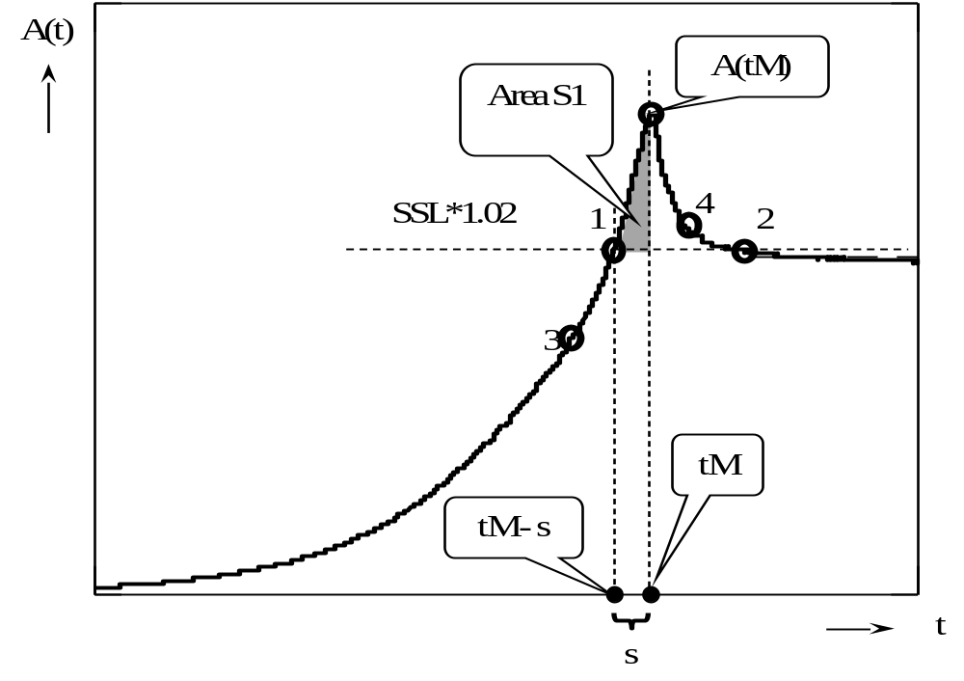

Fig.4. Position of curvilinear triangle and determination of its area S1.

Figure 5 shows the position of curvilinear trapezium that is marked with gray. A location of the vertices of this trapezium is clear from the picture. S2 is area of this curvilinear trapezium.

SSL*1.02
1
t
A(t)
2
4
3
s
tM + s
A(tM)
tM
Area S2

Fig.5. Position of curvilinear trapezium and determination of its area S2.
The calculated shape indices 1…6 include some combinations of the values that are described above.

The expressions used as Shape indices.

Shape index 1 is average derivation of the part of the curve at the interval between points 3 and 1 (marked with gray at Fig. 5).

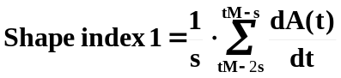

s
SSL*1.02
1
t
A(t)
2
4
3
s
s
tM-s
tM - 2s
A(tM)

Fig.5. Calculating of the Shape index 1.

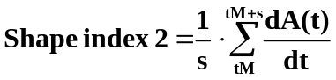

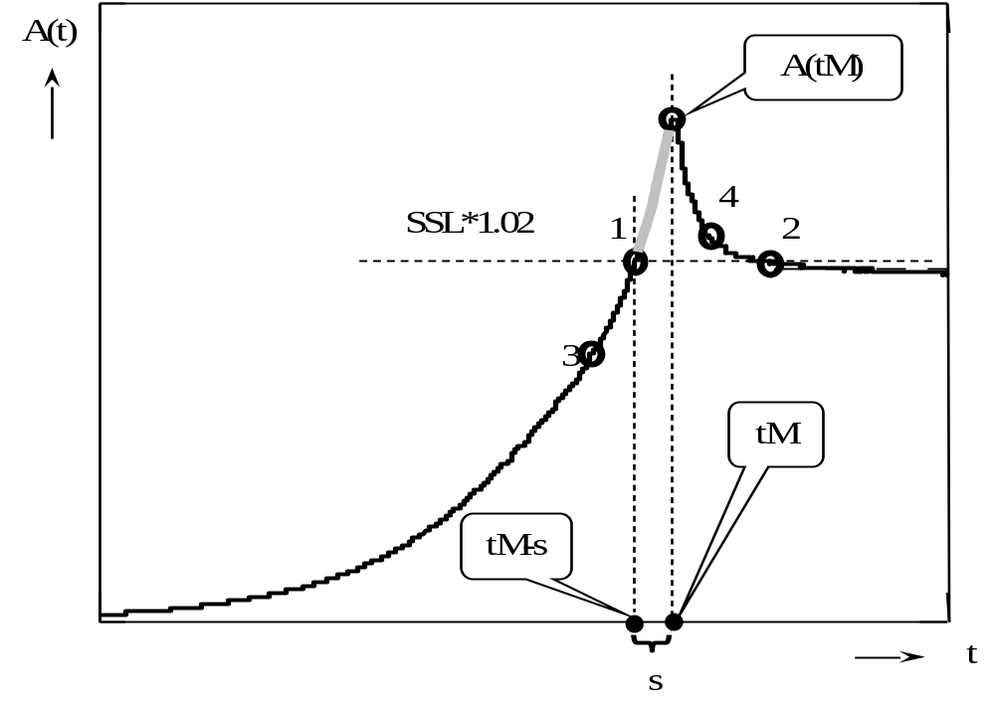

Fig.6. Calculating of the Shape index 2.

Shape index 3 is the difference of the average derivations at the ascending and descending parts of the curve at the interval between points 1 and 4 (marked with gray at Fig. 7).

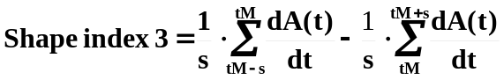

s
SSL*1.02
1
t
A(t)
2
4
3
s
tM-s
tM + s
A(tM)
tM

Fig.7. Calculating of the Shape index 3.

Shape indices 4, 5, 6 have not clear geometrical meaning. They include the values that were shown at Fig. 4, 5.

